PROJECT ON DESIGNING CARGO WINCH
STUDENT NAME:
INSTITUTION:
DATE:

Introduction
Manual handling of cargo at various workplaces is normally detrimental to the material itself together with the those who are employed to handle those material. It most company for example, most of the employees end up developing backbone complications due to heavy weights which they carry when moving one material from one place to the other (Lu et al., 2017). This project aims at developing a cargo winch system which will be a solution to common manual material handling in most workplaces.
Project description
A simple design for the cargo winch is shown in the diagram below.
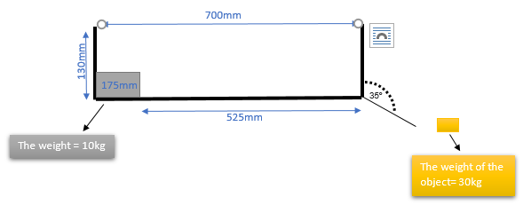
Figure 1: simple design for the cargo winch

The main material that will be used for designing the cargo winch is the steel metal because of its strength and its relative cheapness compared to other metals (Chapman & Roberts, 2013). Working principle of the cargo system will be a pulling system which resembles that of the baggage handling system at various airport. It is expected that the static friction for the steel will range between o.5-0.8 while that of the kinetic friction of the same steel will be 0.42 (Carrion-Vilches et al., 2015). The pulling system is going to be within 17mm and will be at the back of the container. Being that the container will be made of steel, no damage is expected to occur to the container. An example of the baggage handling system at the airport is shown in the figure below.
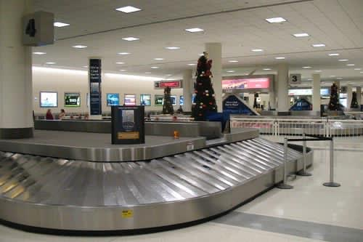
Fig 2: Babbage handling system at the airport

In in this project, the container to be handle as mention earlies is going to be made from steel metal hence making it safe for handling heavy objects but the container itself will be light for easy handling by the cargo winch. the top of the container if left open to allow for easy monitoring of the happenings inside the container. For this project, the object its self to act like a cargo is to be made of steel. The whole project will be similar to the baggage handling at the airport on how it operates but what will make it different from the baggage handling system is that, instead of the cargo being pushed, it will be pulled.
3D design for Cargo Winch (Copy attached)
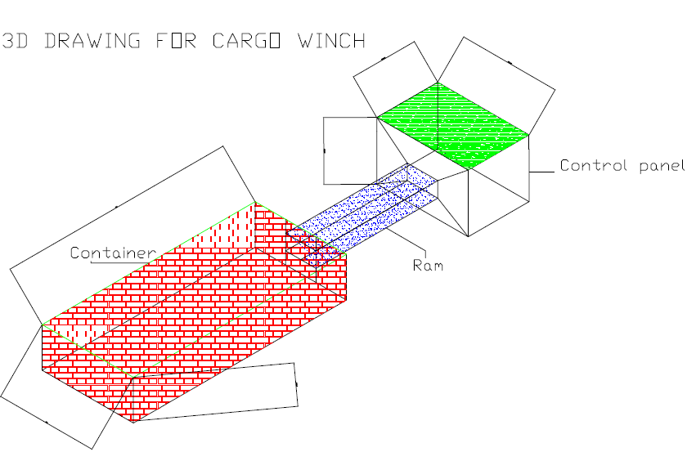

Decision matrix
Ali dashti | Ali Ali | Khaled ALRasheedi | Abdulrahman ALQemlas | Bader Aljeri | Weight % | Measures of Effectiveness
5 | 5 | 3 | 4 | 4 | 30 | Functionality
4 | 2 | 2 | 4 | 4 | 20 | cost
3 | 4 | 4 | 4 | 5 | 15 | safety
4 | 4 | 3 | 3 | 3 | 10 | Efficiency
3 | 4 | 4 | 3 | 4 | 15 | Strength
4 | 3 | 5 | 4 | 4 | 10 | Environmental impacts
4.00 | 3.8 | 3.3 | 3.75 | 4.05 | 100 | TOTAL

In the decision matrix above what makes Badar Aljeri project to be suitable is the safety aspect which even he has gotten 5 points and he is the leading. Safety is very critical in any machine however efficient, lest costly and strong it may be(Bhandari, 2013), without good safely mechanism put in place, then the machine can be disastrous to operators. It is these maximum points (5) gained from safety that has made Badar idea to be taken. His design is also environmentally friendly considering the awarded points (4). Functionality and strength are also relatively good though the efficiency of the design is low compared to the rest such as Ali Ali and Ali Dashti.

Conclusion.
Being that the decision matrix also favors, this cargo winch design. In should be adopted and implemented in those companies which are yet to implement any cargo handling system.

References
Bhandari, V. (2013). Introduction to machine design. Tata McGraw-Hill Education.
Carrion-Vilches, F. J., Bermudez, M.-D., & Fructuoso, P. (2015). Static and kinetic friction force and surface roughness of different archwirebracket sliding contacts. Dental materials journal, 34(5), 648-653.
Chapman, P. F., & Roberts, F. (2013). Metal Resources and Energy: Butterworths Monographs in Materials. Elsevier.
Lu, L., Megahed, F. M., Sesek, R. F., & Cavuoto, L. A. (2017). A survey of the prevalence of fatigue, its precursors and individual coping mechanisms among US manufacturing workers. Applied ergonomics, 65, 139-151.

